**Assignment 5: Create IAM-Roles, Policy & Groups**

**Step 1:**

Go to IAM and click on Add Users.

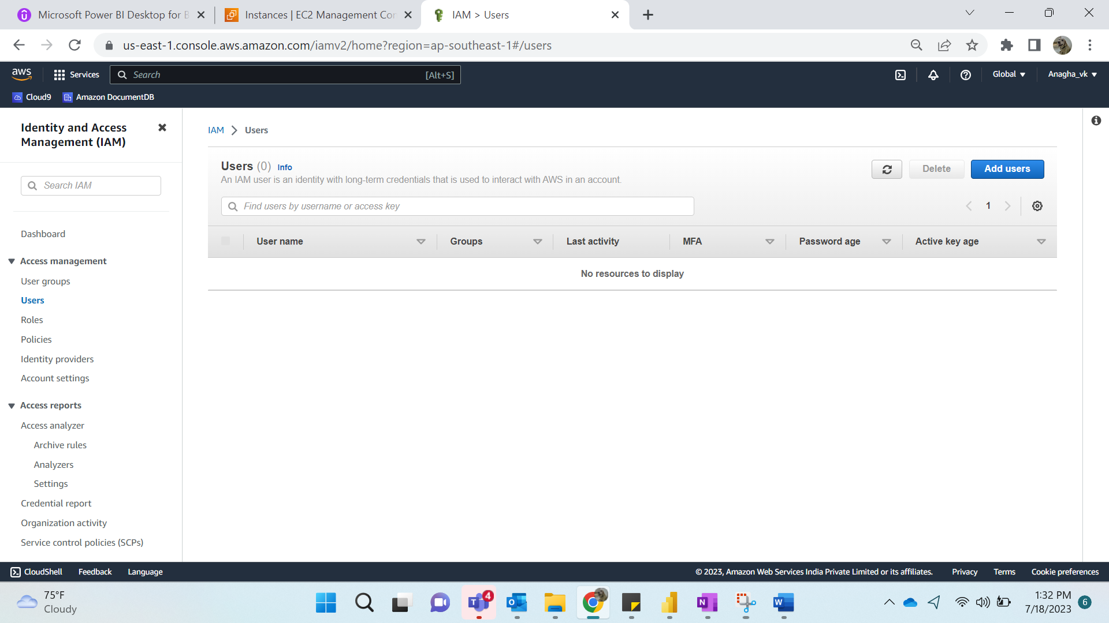

**Step 2:**

Name: AbcXyz

Click on Provide user access to the AWS management Console.

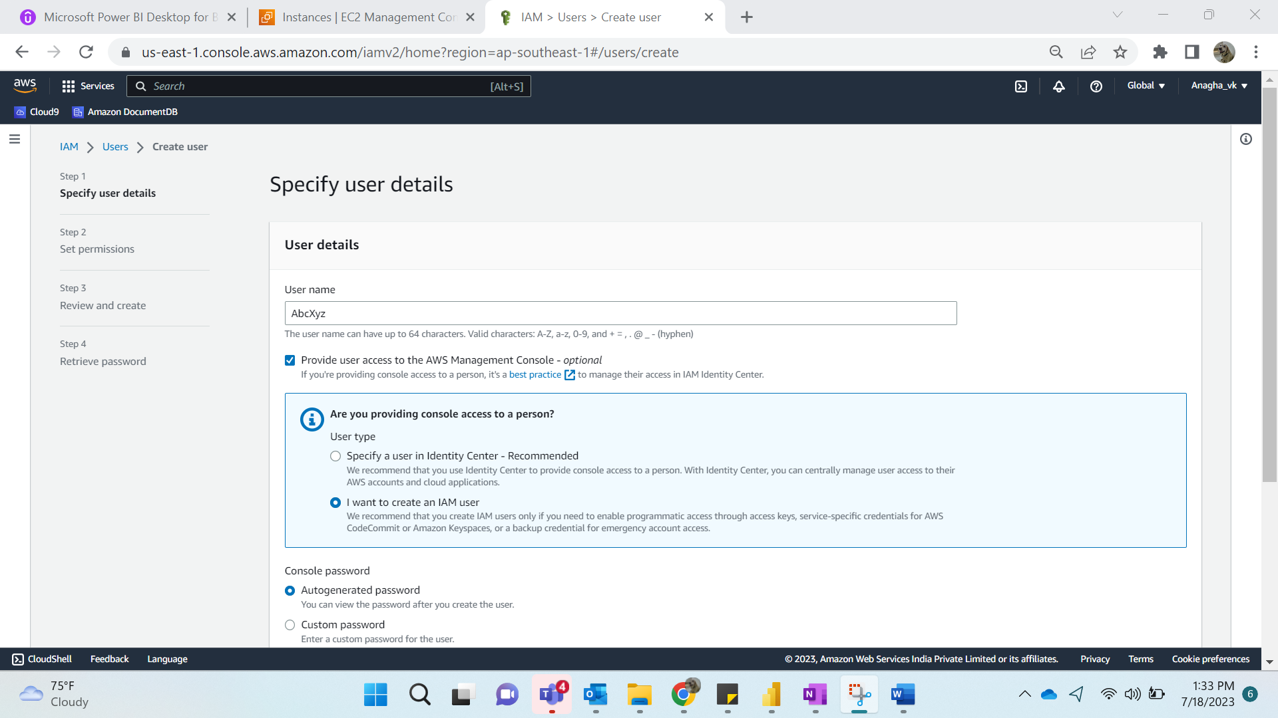

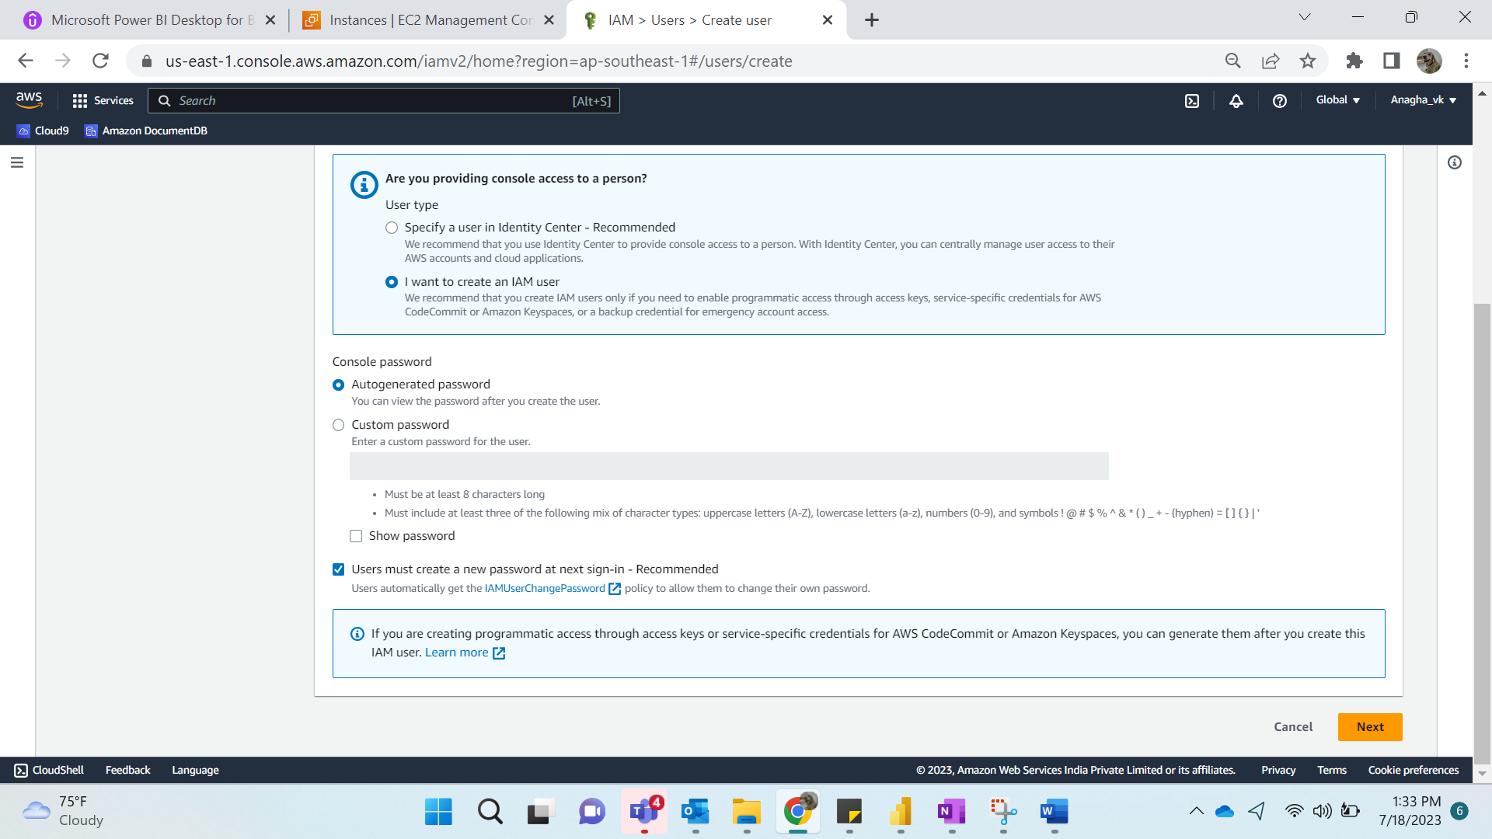

**Step 3:**

Click on Next

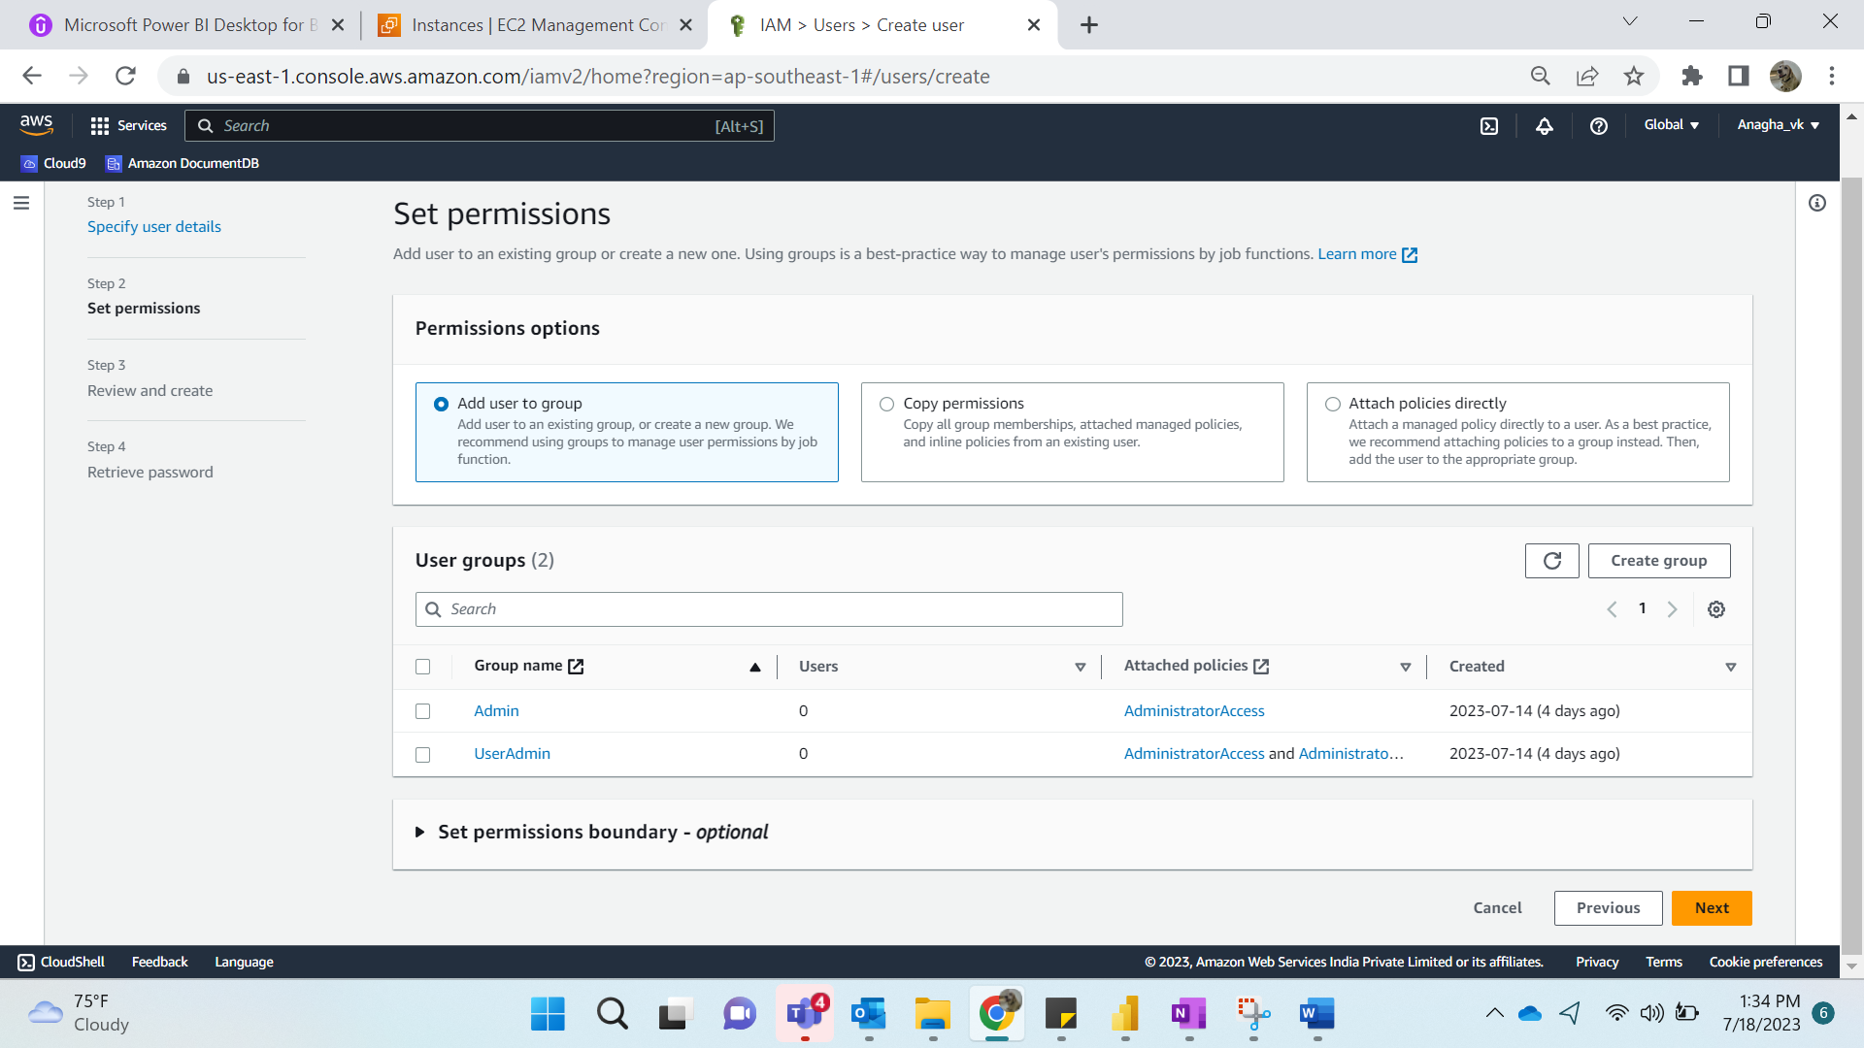

**Step 4:**

Create User

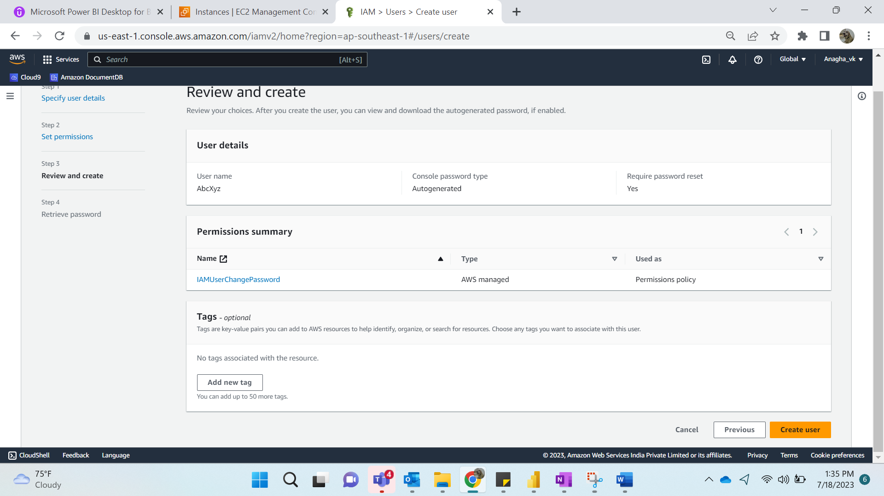

**Step 5:**

Download the .csv and password is also displayed

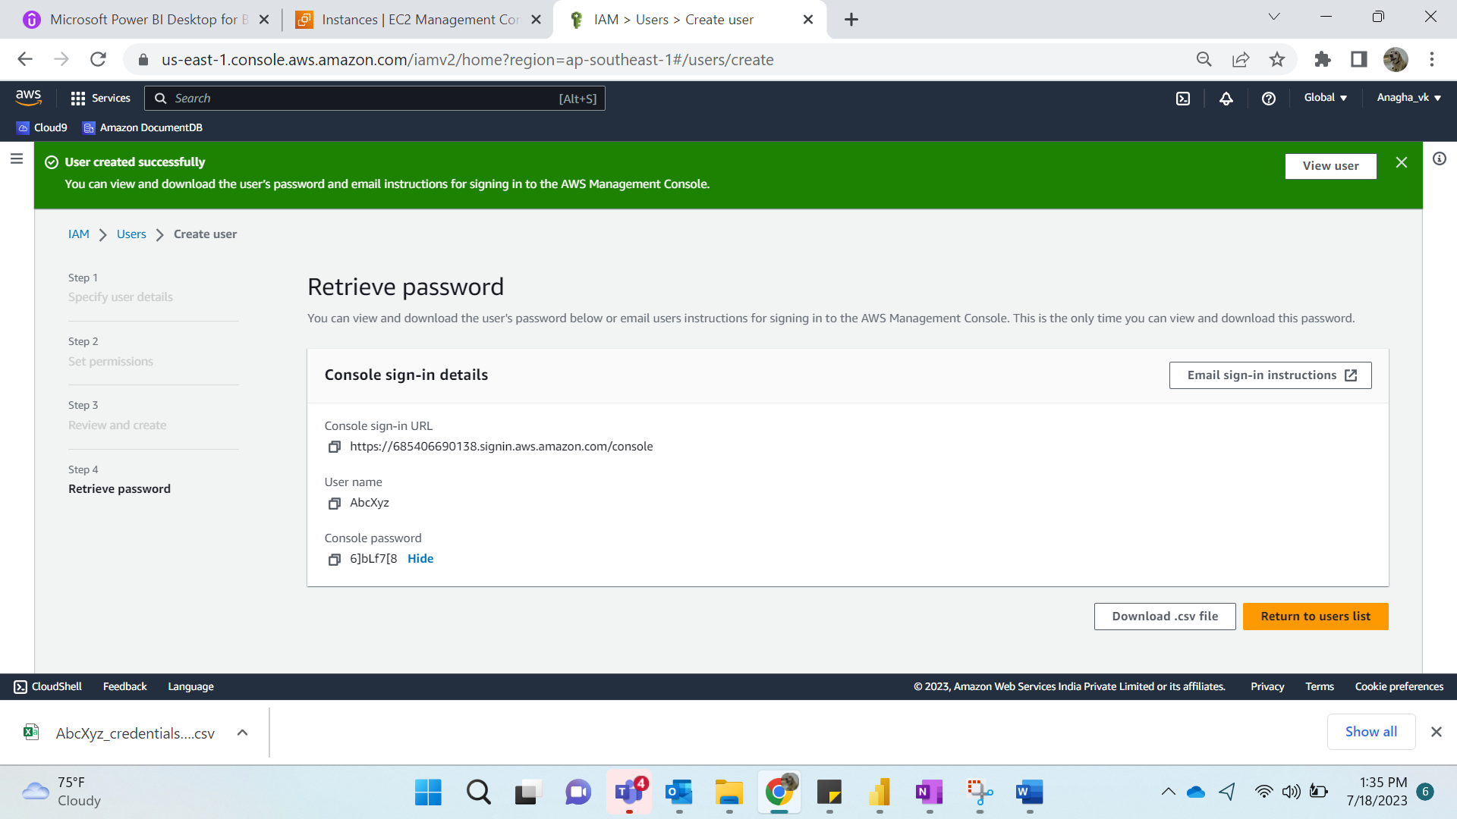

The .csv file is as follows:

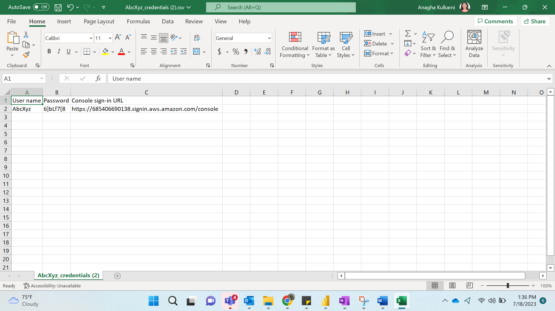

**Step 6:**

Add User to Groups

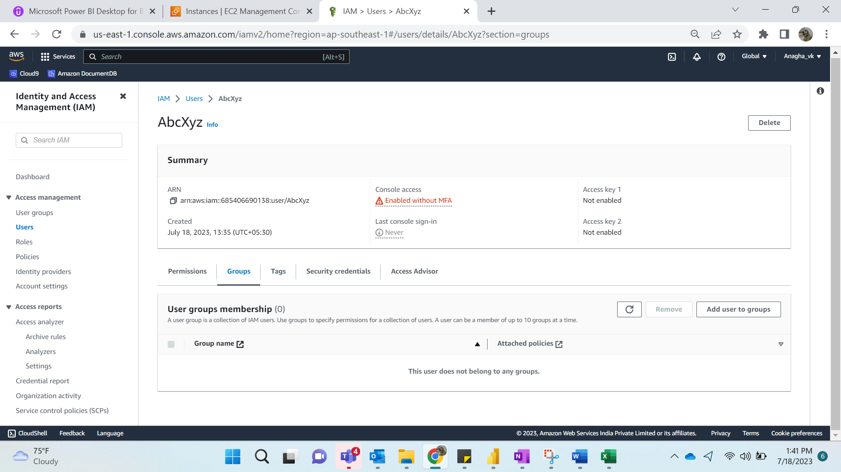

**Step 7:**

Group Name: UserADmin1

Create User Group

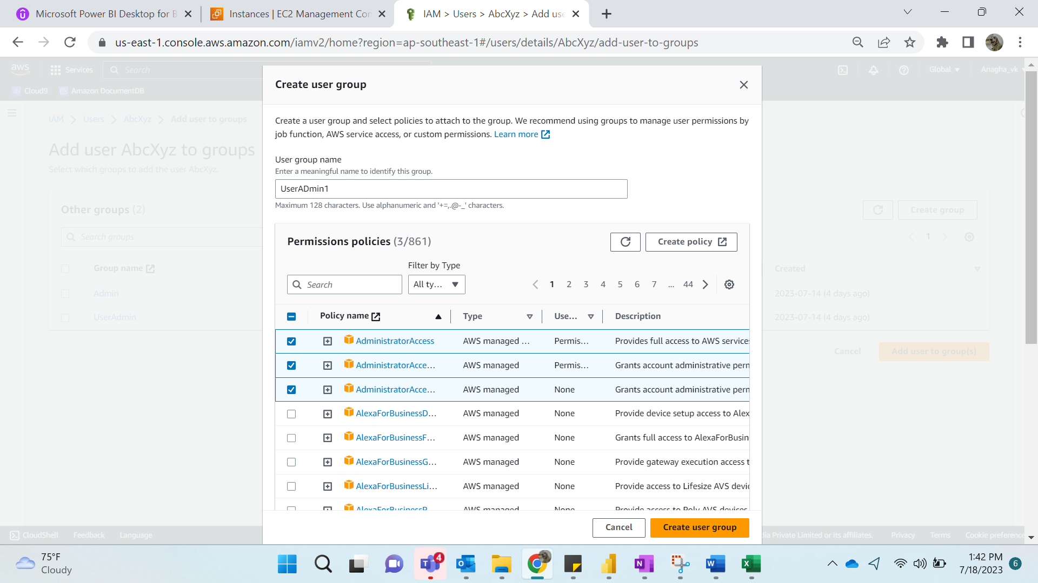

**Step 8:**

Add User to Group

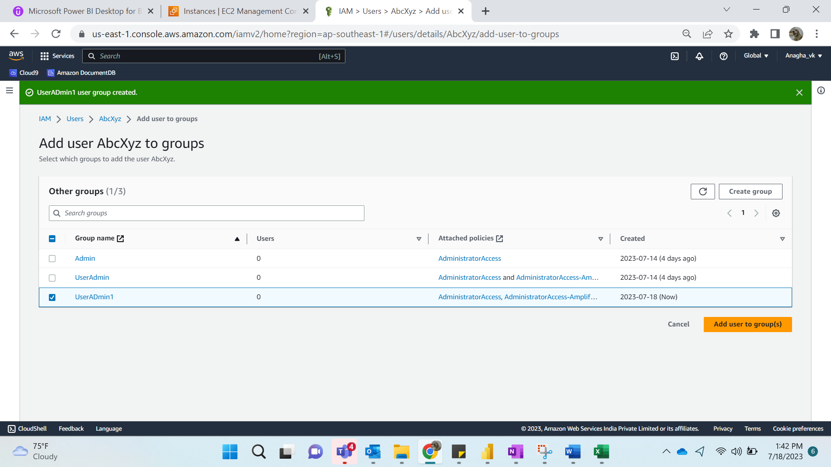

**Step 9:**

We can see group attached to User.

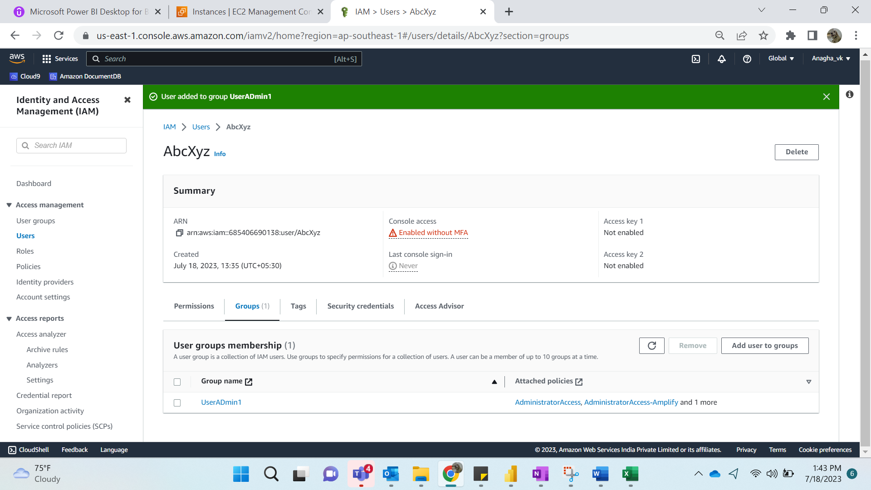

**Step 10:**

Go to Policy->

